Lab 6 VXLAN & Traffic Test

The required files are located in the ~/Downloads/Lab8 folder in vCloud vm since this used to be lab 8

1. Network Overlay :

Network overlays is the latest solution to meet demands, in fact, this technology can speed configuration of new or existing services.

What is Underlay Network?
Underlay Network is physical infrastructure above which overlay network is built. It is the underlying network responsible for delivery of packets across networks.

Physical Network infrastructure is called UNDERLAY. Such as your Network Devices (Switches, Routers), Physical Links(Ethernet, wireless, etc).

Its Hardware Orchestrated. It means, if we want to add a new service, we may require new hardware to be installed and provisioned. Underlay Network is responsible for delivering the Packets.
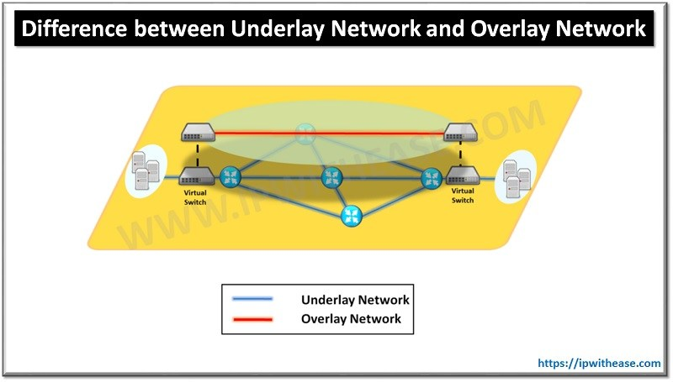
What is Overlay Network?
An Overlay Network is a virtual network that is built on top of underlying network infrastructure (Underlay Network). Actually, “Underlay” provides a “service” to the overlay
This is Sofware Orchestrated. It means, Establishing the Service/Tunnel(Remote connection, Site to Site etc) are done by Software on demand.

Overlay requires encapsulate packets across source to destination. Its a additional overhead

Overlay support Multitenant (overlapping IP addresses)

2. VxLAN:

VXLAN is an encapsulation protocol that provides data center connectivity using tunneling to stretch Layer 2 connections over an underlying Layer 3 network.

In data centers, VXLAN is the most commonly used protocol to create overlay networks that sit on top of the physical network, enabling the use of virtual networks. The VXLAN protocol supports the virtualization of the data center network while addressing the needs of multi-tenant data centers by providing the necessary segmentation on a large scale.

Reference: https://tools.ietf.org/html/rfc7348#page-5

VxLAN means Virtual eXtensible Local Area Network.

A Framework for Overlaying Virtualized Layer 2 Networks over Layer 3 Networks

Primary purpose is used to address the need for overlay networks within virtualized data centers(such as openstack,vmware,etc) accommodating multiple tenants
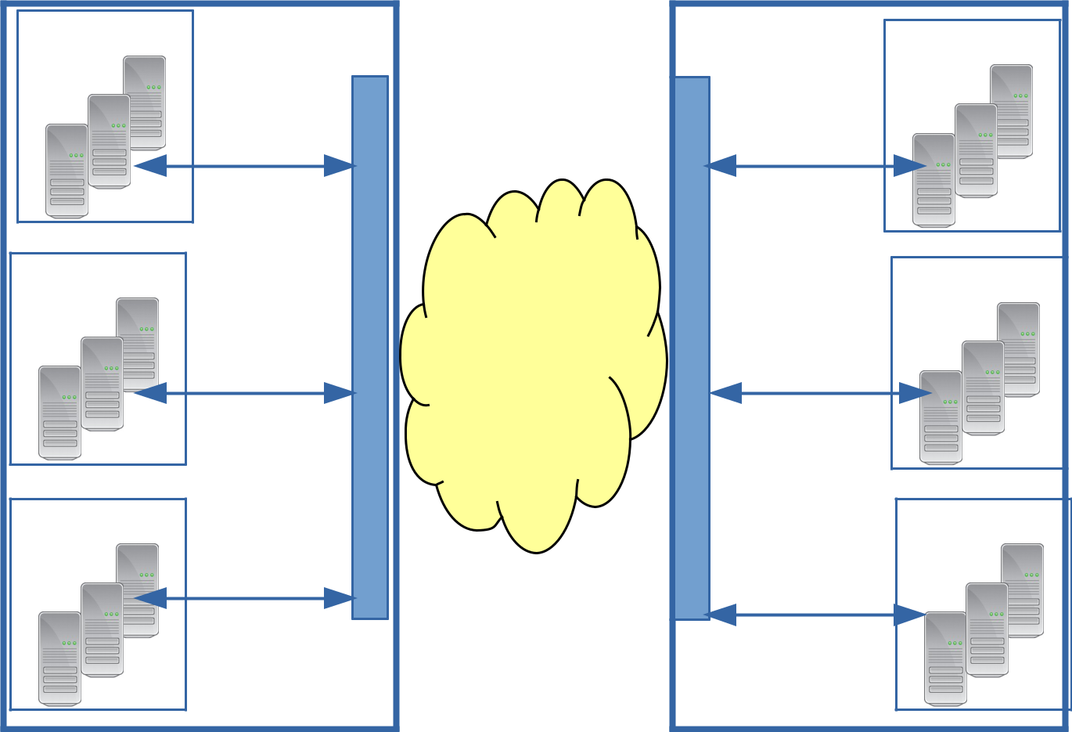

Tenant |  |  |  |  | Tenant
A |  |  |  |  | A
 | 10.1.1.0/2 |  |  |  | 10.1.1.0/2
 | 4 |  |  |  | 4
Tenant |  | S |  | S
Tenant |  | W |  | W | Tenant
B |  | I | INTERNET/ | I | B
 | 172.16.1.0/24 | T | IP NETWORK | T | 172.16.1.0/24
 |  | C |  | C
 |  | H |  | H
Tenant |  |  |  |  | Tenant
C | 10.2.1.0/24 |  |  |  | C
 |  |  |  |  | 10.2.1.0/24
SERVER |  |  |  |  | SERVER
(U.K) |  |  |  |  | (Canada)

Problem Statement:

1. Limitations Imposed by Spanning Tree and VLAN Ranges

A key characteristic of Layer 2 data center networks is their use of Virtual LANs (VLANs) to provide broadcast isolation. A 12-bit VLAN ID is used in the Ethernet data frames to divide the larger Layer 2 network into multiple broadcast domains. This has served well for many data centers that require fewer than 4094 VLANs. With the growing adoption of virtualization, this upper limit is seeing pressure.

2. Multi-tenant Environments

In Cloud Environment, Isolation of network traffic by a tenant could be done via Layer 2. For Layer 2 networks, VLANs are often used to segregate traffic -- so a tenant could be identified by its own VLAN.

In addition, there is often a need for multiple VLANs per tenant, which exacerbates the issue.
Introduction

VXLAN is a Layer 2 overlay scheme on a Layer 3 network.

Each overlay is termed a VXLAN segment. Only VMs within the same VXLAN segment can communicate with each other.

Each VXLAN segment is identified through a 24-bit segment ID, termed the "VXLAN Network Identifier (VNI)". This allows up to 16 M VXLAN segments to coexist within the same administrative domain.
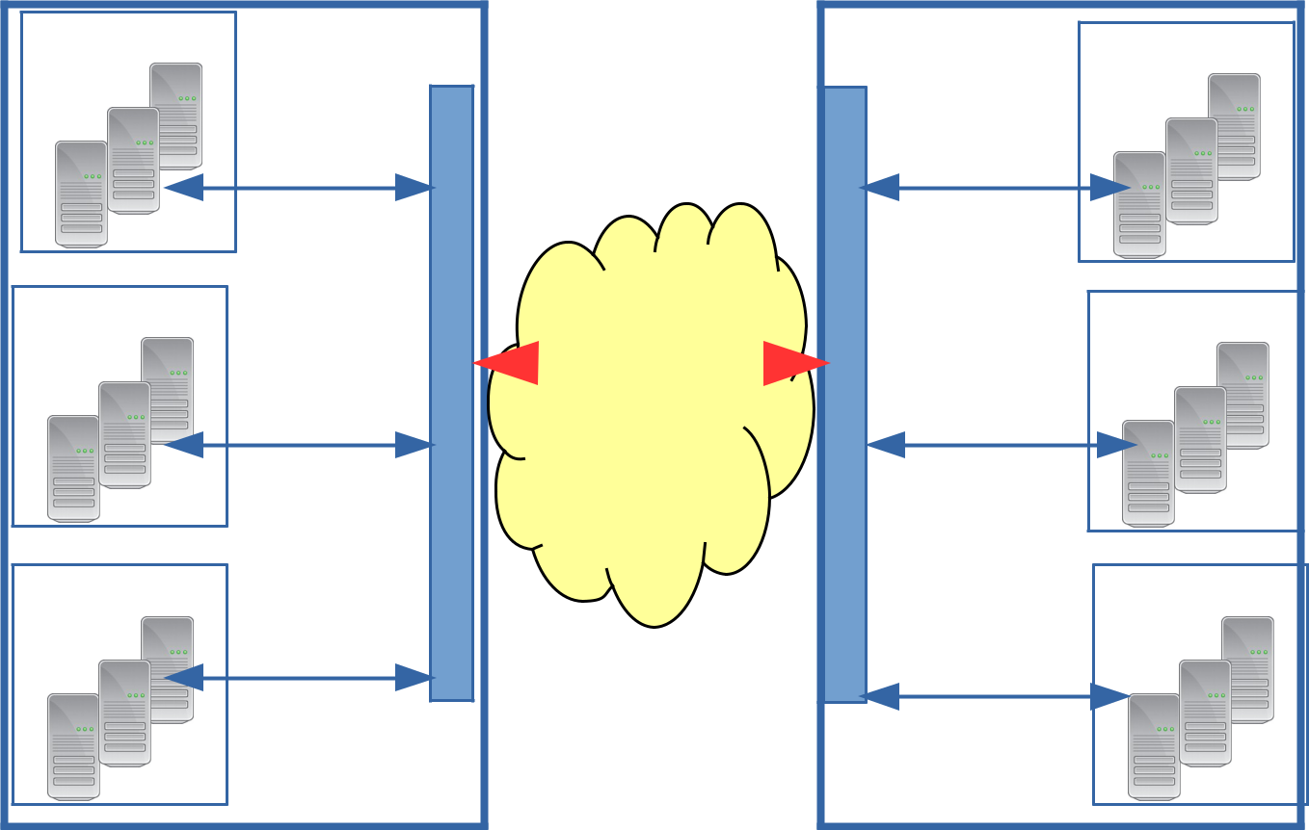

Tenant |  |  |  |  |  | Tenant
A |  |  |  |  |  | A
 | 10.1.1.0/2 |  |  |  | 10.1.1.0/2
 | 4 |  |  |  | 4
 | VNI: 100 | S |  | S | VNI: 100
Tenant |  | W | VXLAN Tunnel | W |  | Tenant
B |  | I | VXLAN Tunnel | I |  | B
B |  | I | INTERNET/ | I |  | B
 | 172.16.1.0/24 | T | IP NETWORK | T | 172.16.1.0/24
 | VNI: 200 | C |  | C | VNI: 200
 |  | H |  | H
Tenant |  |  |  |  |  | Tenant
C | 10.2.1.0/24 |  |  |  | 10.2.1.0/24 | C
 | VNI: 300 |  |  |  | 10.2.1.0/24
 | VNI: 300 |  |  |  | VNI: 300
SERVER |  |  |  |  | SERVER
(UK) |  |  |  |  | (Canada)

The VNI is in an outer header that encapsulates the inner MAC frame originated by the VM. Due to this encapsulation, VXLAN could also be called a tunneling scheme to overlay Layer 2 networks on top of Layer 3 networks.

VTEP - VXLAN Tunnel End Point. An entity that originates and/or terminates VXLAN tunnels

VXLAN Frame Format
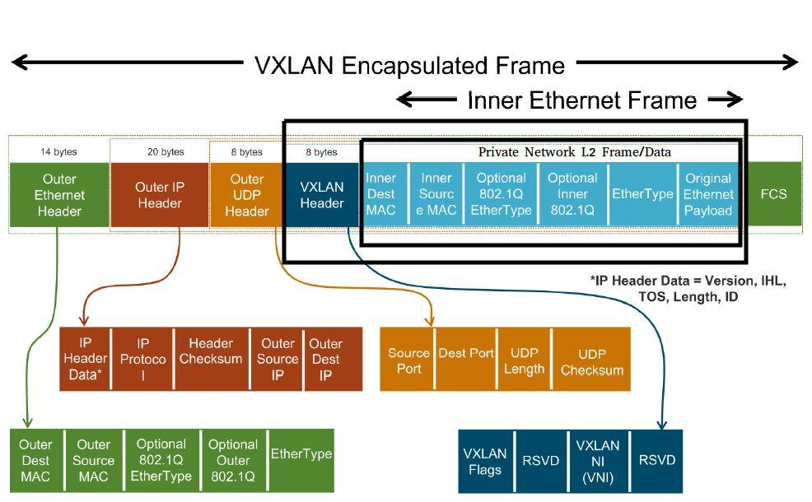

The layer of header is as below,

- Data (Tenant Network – L2 Frame)

- VXLAN Header

- Outer UDP Header

- Outer IP Header

- Outer Ethernet Header

Data: Original L2 frame

VxLAN Header (8 bytes) 1. Flags - 1 byte 2. Segment ID (or VNI) - 3 bytes 3. Reserved - 4 bytes

VXLAN Segment ID/VXLAN Network Identifier (VNI): this is a 24-bit value used to designate the individual VXLAN overlay network on which the communicating VMs are situated. VMs in different VXLAN overlay networks cannot communicate with each other.
Outer UDP Header: Destination Port - 4789 (VXLAN UDP Port)

IP Header: Normal routable IP data Ethernet Header Normal Etherenet frame

3. VxLAN Support in OpenFlow

From openflow 1.3.5 specification document,

- The Tunnel ID field OXM_OF_TUNNEL_ID(match) carries optional encapsulation metadata associated with a logical port.

- When a packet is sent on a logical port that supports the tunnel-id field, it will use the value of that field for internal encapsulation processing. For example, that field may be set by a flow entry using a set-field action.

◦ actions=set_field:100->tun_id

- When a packet is received on a logical port that supports Tunnel ID, the Tunnel ID field associated with the packet is set with the encapsulation metadata and can be matched by flow entries.

Match tun_id=200,

This OXM_OF_TUNNEL_ID is generic one, used for GRE, MPLS, VXLAN. Depends on the logical port the encapsulattion, decapsulation takes place.

4. VxLAN Support in Openvswitch

To create the VXLAN Tunnel Interface(Logical Interface),

- ovs-vsctl add-port switch1 vxlan1 -- set interface vxlan1 type=vxlan \ options:remote_ip=xxxxxxxxx options:key=flow ofport_request=20

Here ofport_request=20 means, the logical port number is 20 in openflow ports.

remote_ip=xxxxxxxx is remote end of the VXLAN tunnel switch.

Note: Make sure the INTERNAL interface already exists in the switch. Otherwise, you need to create a local interface of the switch , using below command,

$ovs-vsctl add-port switch1 vi0 -- set Interface vi0 type=internal

In our case, Internal interface is used for reaching the remote ip of the VXLAN(routing the traffic)

Reference: http://docs.openvswitch.org/en/latest/faq/vxlan/

Helpful video re this lab can be found in

https://www.youtube.com/watch?v=tnSkHhsLqpM

5. VxLAN Demo – Flat Network

Filename : Flat
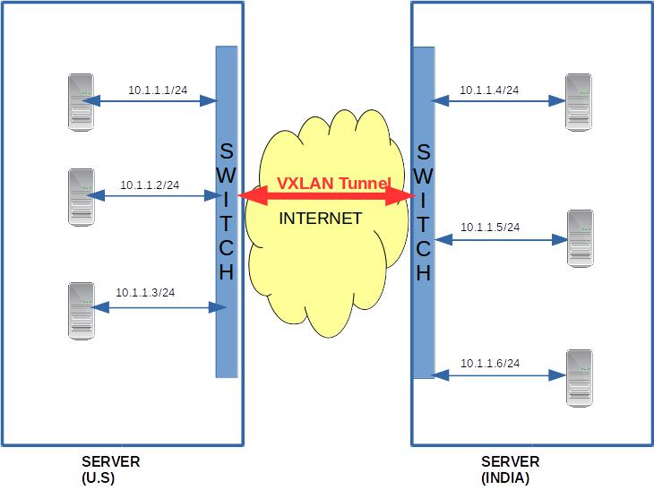
- For demo, we use two Ubuntu VMs. Installed Mininet in those two Vms. You may work with your partner for this lab.

- Run Ryu SDN Controller with simple_switch application on VM1

sudo ryu-manager ryu.app.simple_switch_13

- Run the Topology1 with VM1
sudo python topology1.py

- Run the Topology2 in VM2 sudo python topology2.py

Note : Make sure you update the SDN Controller IP in the Topology file properly, before start the test.

- Test the ping in each topology. mininet> pingall

- Configure the VxLAN between the Two Vms Openvswitch VM1 (IP: xxxxxxx):
sudo ovs-vsctl add-port s1 vxlan1 -- set interface vxlan1 type=vxlan options:remote_ip=xxxxxxxx (ip of vm2)

VM2 ():

sudo ovs-vsctl add-port s1 vxlan1 -- set interface vxlan1 type=vxlan options:remote_ip=xxxxxxx (ip of vm1)

7. Now ping

mininet> a1 ping 10.1.1.4

***************Take screenshot that a1 can ping a4

Sudo ovs-vsctl show //gives you the Vxlan port info

man ovs-vsctl // help for ovs-vsctl commands

If you made mistake with the VxLan creation, you may delete using the following command

Sudo ovs-vsctl del-port VxLan1 [name of VxLan]

Note: the following lab is for multitenant network. Look into the flows and topology files carefully. A potential course project could be to automate these code generation including the make file for the commands. This is a practical case as you may think of the front end VPC creation interface in AWS. At the backend, there are code generators generating the topology and the flows to automate the overlay network.

6. VxLAN Demo – Multi-tenant Networks

Filename: multitenant
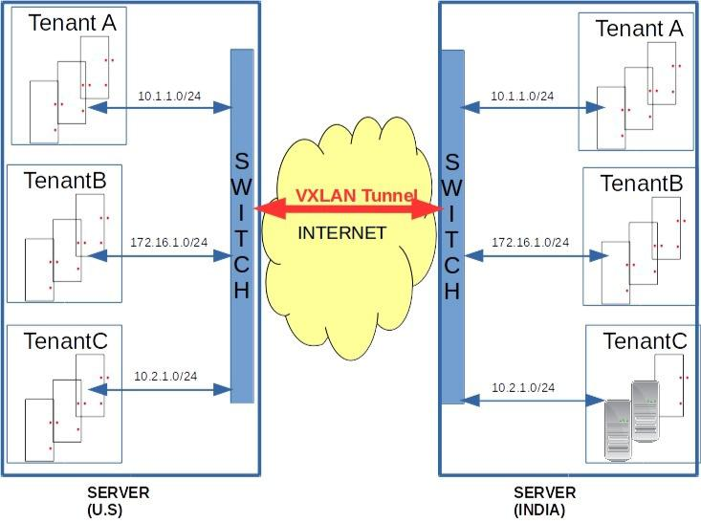

- For demo, we use two Ubuntu 16.04 VMs. Installed Mininet in those two Vms.

- Run mininet topology1 in VM1

sudo python topology1.py

- Run mininet topology in VM2 sudo python topology2.py

3. configure the VXLAN in VM1

sudo ovs-vsctl add-port s1 vxlan1 -- set interface vxlan1 type=vxlan options:remote_ip=(ip of vm2) options:key=flow ofport_request=10

4. configure the VXLAN in VM2

sudo ovs-vsctl add-port s2 vxlan1 -- set interface vxlan1 type=vxlan options:remote_ip=(ip of vm1) options:key=flow ofport_request=10

- Install the openflow rules in VM1 sudo ovs-ofctl add-flows s1 s1_flows.txt sudo ovs-ofctl -O OpenFlow13 dump-flows s1

- Install the openflow rules in VM2

sudo ovs-ofctl add-flows s2 s2_flows.txt

sudo ovs-ofctl -O OpenFlow13 dump-flows s2

- Ping between tenant hosts. mininet> a1 ping 10.1.1.3

*************Take screenshot.

Traffic Tests

1. Introduction
Usually we need to perform various traffic tests between the hosts to test our network topology & SDN application performance.
Some of the test includes:
- TCP Tests between two hosts
- UDP Tests
- UDP Tests with different Packet size (64 bytes, 1024 bytes etc), different packet rate (50 pkts/s, 100 pkts/s etc)
- Variable Traffic rate (10Pkts/s for first 60s, then 100Pkts/s for rest of the test )
- Multiple/Parallel Streams/Sessions
- VoIP Traffic Test
- Video Streaming mp4 video file will be used as video source. and will generate the video stream using VLC, and will be received by client using VLC Video Player.
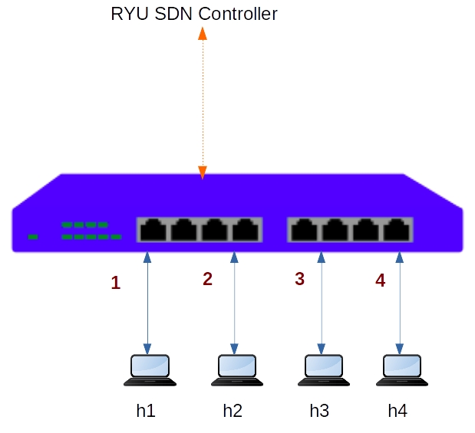

2. TCP Tests
IPERF is widely accepted traffic generation tool to perform TCP Tests.
- TCP tests generally used for measure the bandwidth.
- Latency, Jitter, Packet loss cannot be measured using TCP Tests.

For all our traffic tests, we will use Simple Topology and l4 switch application.
- Create the topology

sudo mn --controller=remote,ip=127.0.0.1 --mac --switch=ovsk,protocols=OpenFlow13 --topo=single,4

- Run the RYU Controller l4 switch applicaion.
ryu-manager l4_switch.py
- In mininet shell, do ping h1 to h2.
mininet>h1 ping -c 5 h2
4.check the flows
sudo ovs-ofctl -O OpenFlow13 dump-flows s1
- understand the Host & Switch Port numbers.
mininet>links
mininet>ports
- To check the switch statistics
sudo ovs-ofctl -O OpenFlow13 dump-ports s1
Now all set to run our traffic tests.

A. Traffic test from h1 to h4
Objective: Generate TCP Traffic from h1 to h4. (Measure bandwidth from h1 to h4)
h1 is sender.
h4 is receiver.
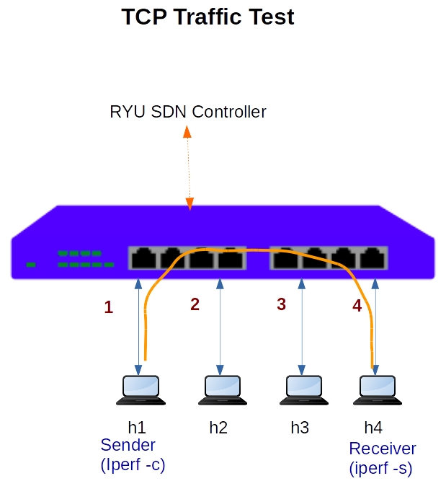
- Start IPERF Server in h4
h4 iperf -s &
- Start the IPERF Client in h1 and connecting to h4
h1 iperf -c h4
- Analyze the results by flows
sudo ovs-ofctl -O OpenFlow13 dump-flows s1
we observe traffic in both directions.
h1 to h4 traffc is very high (in Gbps). This is data traffic. h4 to h1 traffic is very less. This is TCP Acknowledge traffic.
- Analyze the results by ports.
sudo ovs-ofctl -O OpenFlow13 dump-ports s1
h1 --------port1, port4--------h4
Forward traffic:
- h1 transimits. port1 receives.
- port4 transmits, h4 receives.
Acknowlege:
- h4 transmits. port4 receives.
- port1 transmits. h1 receives.

B. Bidirectional Traffic test h1 to h4(sequentially).
- Start IPERF Server in h4
h4 iperf -s &
- Start the IPERF Client in h1 and connecting to h4
h1 iperf -c h4 -r
Its sequential test , once h1 to h4 traffic test is completed it will start h4 to h1 traffic test.

C. Bidirectional Traffic test h1 to h4(parallel).

- Start IPERF Server in h4
h4 iperf -s &
- Start the IPERF Client in h1 and connecting to h4
h1 iperf -c h4 -d
Its parallel test , both direction h1 to h4 as well h4 to h1 traffic tests started.

D. Traffic test from h1 to h4 with Multiple Sessions.

- Start IPERF Server in h4
h4 iperf -s &
- Start the IPERF Client in h1 and connecting to h4
h1 iperf -c h4 -P 5

3. UDP Tests with IPERF
UDP Tests are quite flexible in the nature of playing around packet sizes(64 bytes) and number of packets(10 Packets/s) you want to send. It means, user can control the bandwidth of UDP Traffic.
- Bandwidth, Latency, Jitter, Packet loss can be measured using UDP Tests.
IPERF doesnot provide provide much flexibility in UDP Tests.

- Start IPERF UDP Server in h4
h4 iperf -u -s &
- Start the IPERF Client in h1 and connecting to h4 and generate bandwidth of 10Mbsp
h1 iperf -u -c h4 -b 10m

*************Take screenshot and explain how can you compute bandwidth of a specific port from the above experiments.

4. VOIP Tests
VOIP Traffic is UDP Stream. This can be simulated thru IPERF UDP Tests.
Objective
- Test the single Voip call 64Kbps
- Test parallel voip calls
Testing
- Create the topology
sudo mn --controller=remote,ip=127.0.0.1 --mac --switch=ovsk,protocols=OpenFlow13 --topo=single,4
- Run the RYU Controller l4 switch applicaion.
ryu-manager l4_switch.py

A. Single 64Kbps VOICE CALL Test
start the 64Kbps VOIP Traffic Test between h1 to h4 for 60 seconds ,and vice versa.
1) Run the IPERF UDP server in h4
In mininet CLI
mininet>h4 iperf --server --udp --len 300 --tos 184 -fk --interval 5 &
Here we are starting udp server, and setting the TOS field to 184

2) Run the IPERF UDP Client in h1
In mininet CLI
h1 iperf -c 10.1.1.4 --udp --len 300 --bandwidth 67000 --dualtest --tradeoff --tos 184 -fk --interval 5 --time 60 --listenport 5002

B. Multiple Parallel calls VOIP calls test
1) Run the IPERF UDP server in h4
mininet>h4 iperf --server --udp --len 300 --tos 184 -fk --interval 5 --parallel 4

2) Run the IPERF UDP Client in h1
mininet>iperf -c 10.1.1.4 --udp --len 300 --bandwidth 67000 --dualtest --tradeoff --tos 184 -fk --interval 5 --time 60 --listenport 5002 --parallel 4

References

https://www.cisco.com/c/en/us/products/collateral/switches/nexus-9000-series-switches/white-paper-c11-729383.html

http://docs.openvswitch.org/en/latest/faq/vxlan/

https://blog.remibergsma.com/tag/vxlan/

http://wiki.innovaphone.com/index.php?title=Howto:Network_VoIP_Readiness_Test
https://www.videolan.org/index.html
http://docs.openvswitch.org/en/latest/howto/userspace-tunneling/

http://www.rajeevsrikant.com/blog/vxlan-basics/
http://docs.openvswitch.org/en/latest/faq/vxlan/
https://securelink.be/blog/vxlan-overlay-protocol/
https://tools.ietf.org/html/rfc7348

